Summer Assignment- AP Drawing and Design 2019-20
ASSIGNMENT:
• You will complete a minimum of 5 projects over the summer as your AP Studio Art class preparation. These assignments will be due August 19th and will be critiqued in class. You will receive a major grade for your summer work. Please pick 5 and complete one of each of the assignments from the list below. If you are a 10th grader I would really like you to complete all 7. Pieces should be between 8X10” and 18X24” in size – the assignments are about quality. You may use any media or mixed media of your choice. Even though this AP section is called drawing the primary emphasis is your mark making, so you can use any medium that represents that. You are encouraged to explore media, techniques and approaches you have not used before. These pieces are work for your portfolio. These should be PORTFOLIO quality. Please consider the back ground. WHITE GROUNDS are generally frowned upon unless it aides in your composition. These need to feel finished. See portfolios examples at http://apcentral.collegeboard.com

Join Pinterest + remind101: AN EASY FIRST GRADE.
- Create a Pinterest account at pinterest.com. “Follow” me, vicatron@gmail.com, and I will follow you back. You will create a board named “AP Inspiration”. You will pin at least 50 images that inspire you, the goal is to become aware of artistic styles, new mediums and generally become visual consumers. This is a grade due on your first day of class! We will utilize Pinterest all year long. I will post some examples that relate to these projects on the AP Draw board I have on my own Pinterest account.
- Sign up for our class remind - TEXT 81010 message @sattyap20
Project Choices (7):
  - A self-portrait that uses multiple types of mark making and exemplifies exaggeration. Use an odd/extreme angle and consider strong contrast. You can choose any media but distort and exaggerate. 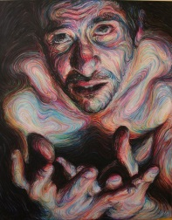 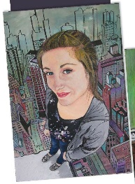 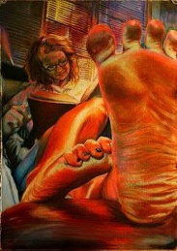 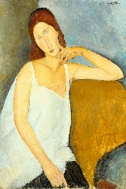 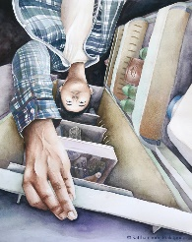
  - Still life arrangement of 3 or more reflective objects. Your goal is to convey convincing representation. Sketch and shade for contrast and drama. Objects may include but are not limited to, cutlery, puddles, etc.
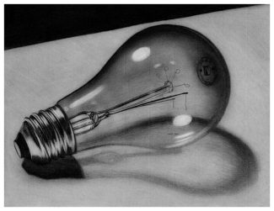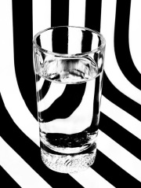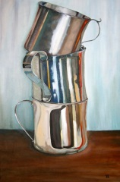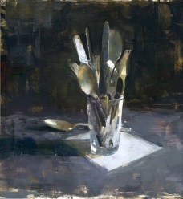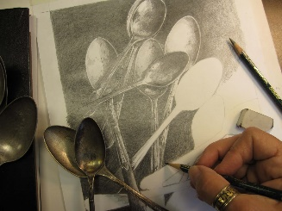
  - A drawing of an unusual interior – for example, look inside a closet or cabinet, in the refrigerator, under the car’s hood or inside the medicine cabinet. Detailed and visually interesting.
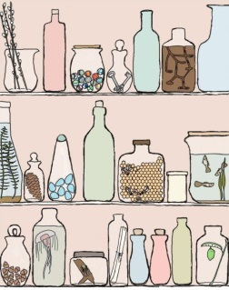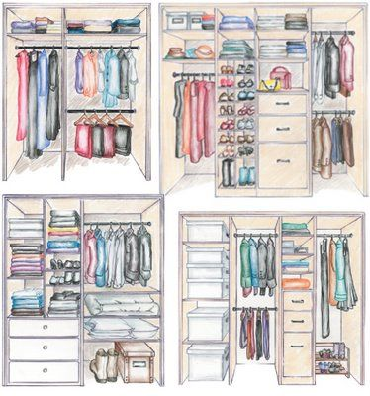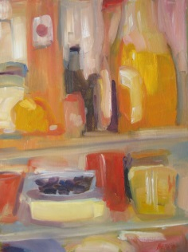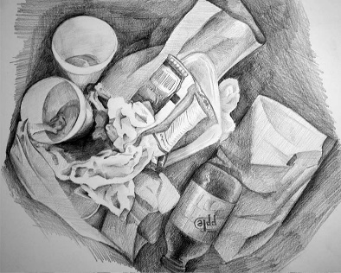
  - Pick a type of texture, zoom in so close that the entire composition appears abstracted or distorted. Concentrate on creating a good balance of this texture and negative space.
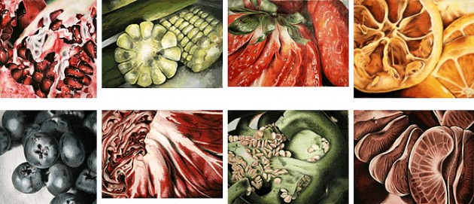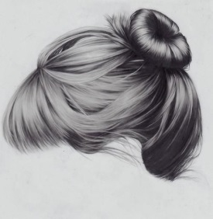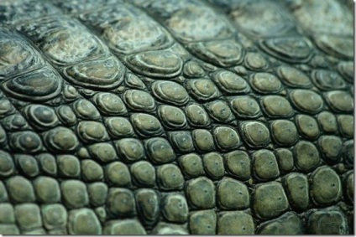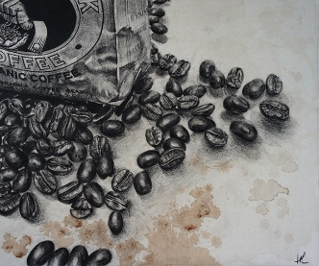
- Choose one- A realistic landscape that encompasses Fore, mid and back ground (perhaps? use some architecture too!) OR imagine a landscape that is from a far off planet. Again- looking for Foreground, mid ground and background. Depth of Field.
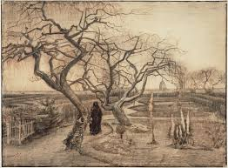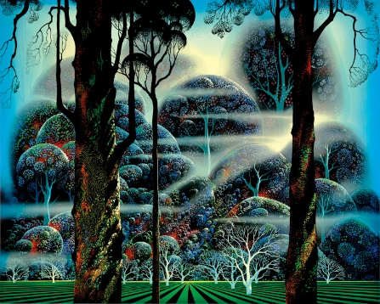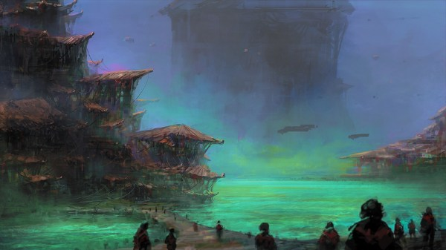
- Surreal drawing.
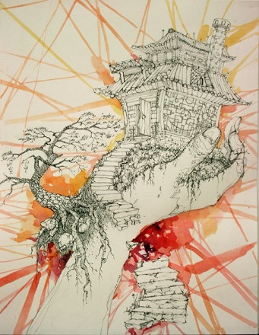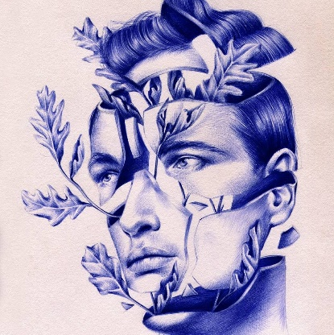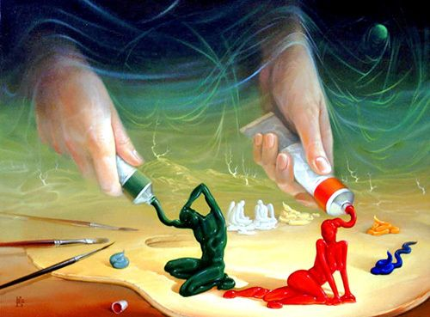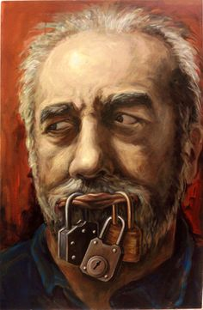

- Definitions. See attached page from one of my vintage dictionaries. Find one word that interests you on the page and make a composition based on this word or its meaning.

You may pick up paper before the last day of school and may email me at any time with questions or concerns. vlee@alvinisd.net. I am looking forward to seeing great work in August!

